
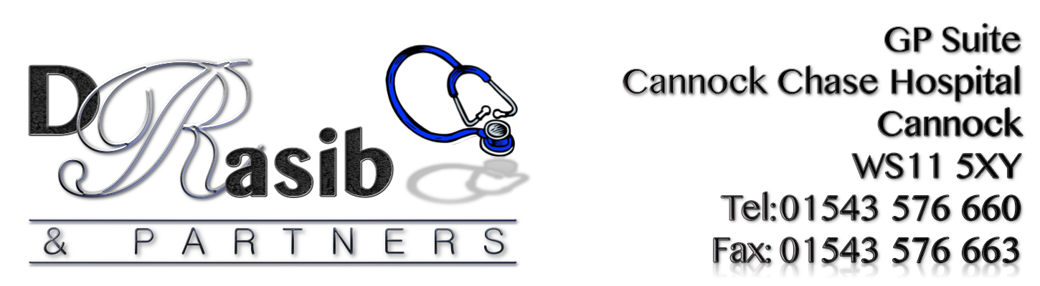

NHS FRIENDS & FAMILY TEST

“HOW LIKELY ARE YOU TO RECOMMEND OUR SERVICE TO
FRIENDS AND FAMILY IF THEY NEEDED SIMILAR CARE
OR TREATMENT?”

May 2019 RESULTS





Extremely Likely | Likely | Neither Likely/ Unlikely | Unlikely | Extremely Unlikely | Don’t Know
88 | 16 | 2 | 4 | 6 | 0

Comments Received from Patients included:
‘Both the receptionist who booked the appointment and the nurse I saw were very friendly and professional’
‘Easy to get appointment and professional’
‘Always treated well, thank you’
‘Dealt with promptly and in a courtesy manner’
‘Very efficient, friendly practice’
‘Friendly and efficient service’
‘Very polite, helpful and quick, no waiting around’
‘I have always been seen quickly and dealt with in a pleasant way’
‘Everyone is so helpful and friendly’
‘Good efficient service. Pleasant staff. Knowledgeable practitioner’
‘All staff at this practice are kind, considerate and very professional’
‘Feel listened to and supported’
‘Their dedicated to all their patients whenever you go’
‘Excellent service’
‘Always a caring and courteous practice who listen’
‘Extremely efficient and friendly’
‘Top quality care’

HAVE YOUR SAY TODAY…
COMPLETE A FRIENDS & FAMILY QUESTIONNAIRE

